**LRU Algorithm**

#include<stdio.h>

main()

{

int q[20],p[50],c=0,c1,d,f,i,j,k=0,n,r,t,b[20],c2[20];

printf("Enter no of pages:");

scanf("%d",&n);

printf("Enter the reference string:");

for(i=0;i<n;i++)

scanf("%d",&p[i]);

printf("Enter no of frames:");

scanf("%d",&f);

q[k]=p[k];

printf("\n\t%d\n",q[k]);

c++;

k++;

for(i=1;i<n;i++)

{

c1=0;

for(j=0;j<f;j++)

{

if(p[i]!=q[j])

c1++;

}

if(c1==f)

{

c++;

if(k<f)

{

q[k]=p[i];

k++;

for(j=0;j<k;j++)

printf("\t%d",q[j]);

printf("\n");

}

else

{

for(r=0;r<f;r++)

{

c2[r]=0;

for(j=i-1;j<n;j--)

{

if(q[r]!=p[j])

c2[r]++;

else

break;

}

}

for(r=0;r<f;r++)

b[r]=c2[r];

for(r=0;r<f;r++)

{

for(j=r;j<f;j++)

{

if(b[r]<b[j])

{

t=b[r];

b[r]=b[j];

b[j]=t;

}

}

}

for(r=0;r<f;r++)

{

if(c2[r]==b[0])

q[r]=p[i];

printf("\t%d",q[r]);

}

printf("\n");

}

}

}

printf("\nThe no of page faults is %d",c);

}

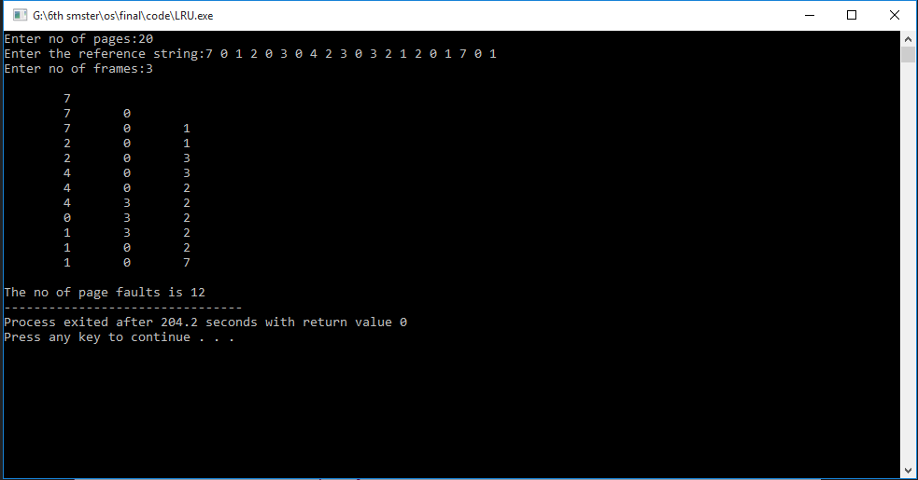**Output:**